12th Steering Group Meeting
When: 8. – 9. June 2017
Where: Otto Wagner Schützenhaus, Obere Donaustraße 26, 1020 Vienna
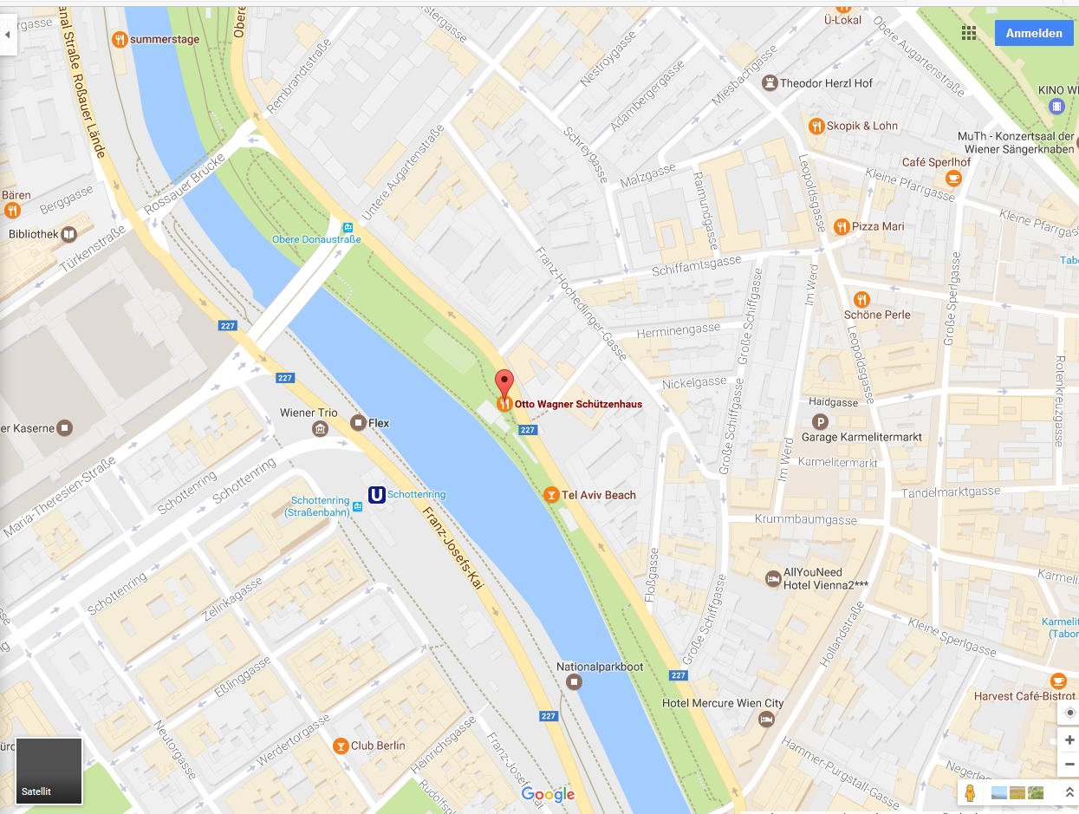

How to reach the venue:
Metro:
The venue is located in the 2nd district called Leopoldstadt. The easiest way to get there is by underground railway train U2 (purple coloured) to stop “Schottenring”, exit “Herminengasse”.
It is also reachable via U4 (green line) at stop “Schottenring”. ATTENTION: If you take this line you will find yourself on the wrong side of the Danube Canal! You can reach the other side most easily, if you go to metro U2, (Schottentor is a crossing station) walk along the rails and take exit “Herminengasse”.
Per Foot from Schwedenplatz:
The venue is quite close to the center of Vienna. If you find yourself at “Schwedenplatz” (metro U1 and U4 as well as several trams) you might best cross the Danube Canal, go downstairs to the promenade of the Danube Canal and walk until you reach the venue. (10 min approx.)
From airport:
Option 1: You take the Airport Bus (line 2), which stops at Schwedenplatz, and go to the venue per foot.
Option 2: You take the train until stop “Wien Mitte/Landstraße” and take metro U4 until stop “Schottenring” (see above).
Information on public transportation
http://www.wienerlinien.at/eportal3/ep/tab.do?tabId=0
Taxi
Taxi 40 100 Taxifunkzentrale GmbH
Pfarrg 54, 1230 Wien
Tel: +43(1)61455…-0
Fax: +43(1)61455-838
Web: www.taxi40100.at
Some suggestions for convenient accommodation

MEININGER Hotel Wien Downtown Franz
Rembrandtstraße 21, 1020 Wien
welcome@meininger-hotels.com
https://www.meininger-hotels.com/de/hotels/wien/downtown-franz/

Hotel Bajazzo
Esslinggasse 7
1010 Wien
+43 1 533 89 03
info@hotelbajazzo.at
http://www.hotelbajazzo.at/

VOX Design Hotel
Phone: +43 1 9073377
E-mail: office@vox-hotels.com
Mail: Schreygasse 2, 1020 Vienna
http://vox-hotels.com

Hotel Resonanz Vienna
Taborstraße 49
1020 Wien
01 9553252
http://www.adler-hotels-wien.at/hotel-resonanz

Austria-Trend Rathauspark
Rathausstraße 17
1010 Wien
rathauspark@austria-trend.at
https://www.austria-trend.at/de/hotels/rathauspark

Hotel Regina
Rooseveltplatz 15
1090 Wien
regina@kremslehnerhotels.at
http://www.kremslehnerhotels.at/de/hotel-regina-wien/

Hotel Austria
Fleischmarkt 20
1010 Wien
office@hotelaustria-wien.at
https://www.hotelaustria-wien.at/

Tourist Information
For information on vienna visit the toursit information website https://www.wien.info/de

